Project CM

Version 1.0

Revision History

|  |  |  |  |
| --- | --- | --- | --- |
| Date | Version | Description | Author |
| 09/Apr/2014 | 1.0 | Initial UC description | Storm Cloud Development |
|  |  |  |  |
|  |  |  |  |
|  |  |  |  |

Table of Contents

1. Use-Case logout 4

1.1 Brief Description 4

1.2 Stored data 4

2. Flow of Events 4

3. Special Requirements 5

4. Preconditions 5

5. Postconditions 5

6. Extension Points 5

7. Cucumber test scenario 5

8. Mockups 5

9. Function Points 6

# Use-Case logout

## Brief Description

The use case logout is for destroying the session of the user. He clicks logout and is not able to use any sites which require a logged in user.

## Stored data

None

# Flow of Events

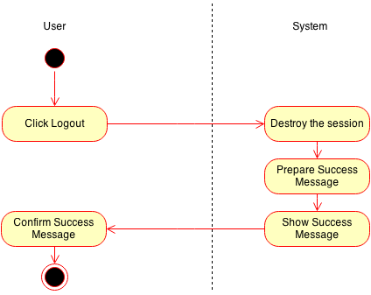

# Special Requirements

n/a

# Preconditions

The user must be logged in.

# Postconditions

The user is not logged in anymore.

# Extension Points

n/a

# Cucumber test scenario

n/a

# Mockups

n/a

# Function Points

Below you can see the function point calculation for this use case.

